Installing Your New Heritage 18 Karat Gold Nib
By Lou Metcalf
www.heritagepens.com

Fountain pen nibs can appear mysterious and foreboding but with just a little effort and a little patience you can change a nib yourself. Of course, you will probably want to give all of the parts a good thorough cleaning with clear, lukewarm water at the same time.

To begin, here is a picture of the components and names that I will use for reference in the rest of the article.

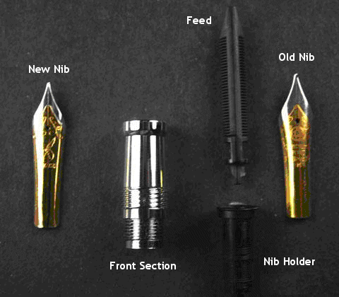

Step 1

Remove the entire front section from the pen by unscrewing it from the barrel. Make sure your replacement nib is made to fit as a replacement. Adjustments to adjust fit can be made, but will not be addressed here.
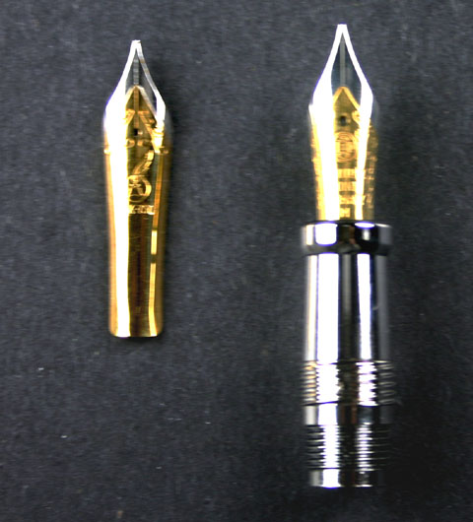
Step 1

Step 2

Unscrew the nib holder from the section. NOTE: This is not required for all nib replacements.
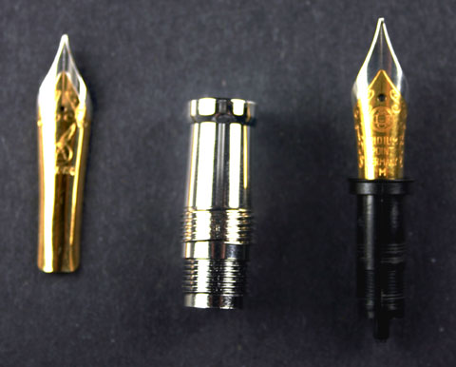
Step 2

Step 3

Grasp the nib and feed between your thumb and index finger and pull it out of the nib holder. NOTE: The nib and feed should be pinched between your thumb and finger below (away from) the wings and tip. This may require a bit of wiggling or even soaking the holder in warm water for 15 -20 seconds.
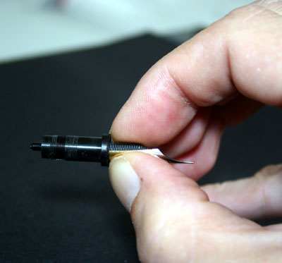
Step 3a
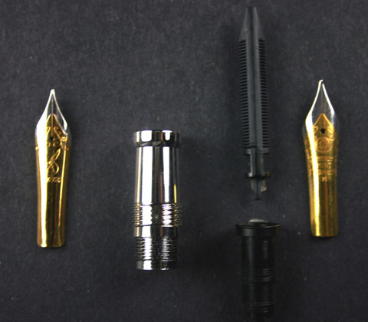
Step 3b

Step 4

Center the feed on the new nib as shown below.
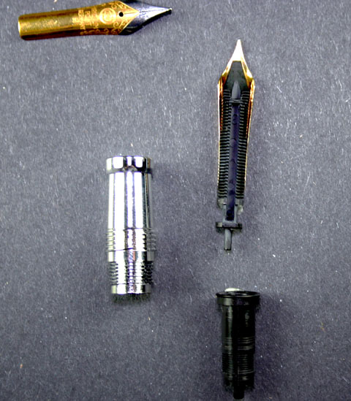
Step 4

Step 5

Slide the new nib and feed into the nib holder until it seats and bottoms out in the holder. Make certain that the feed is still centered on the feed. NOTE: The nib and feed can be seated in the nib holder first and then screwed into the front section of the nib holder and front section can be screwed together and then the nib and feed can be seated.
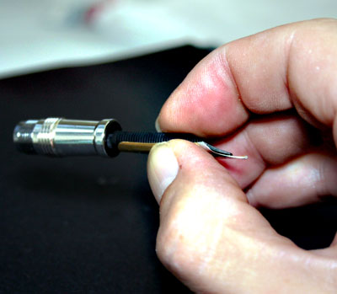
Step 5a
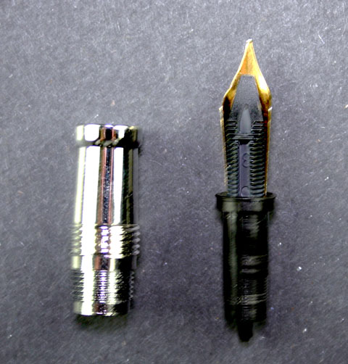
Step 5b

Step 6

Screw the assembled nib, feed and nib holder back into the section, being sure to keep the nib-feed alignment.
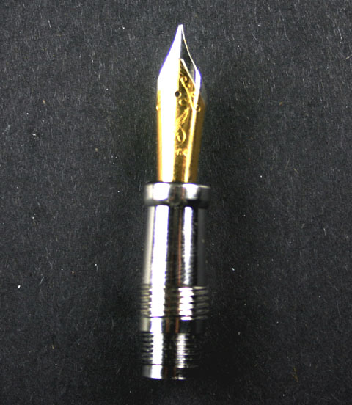
Step 6

You have successfully changed your nib. Ink-up and enjoy your new nib!

